VII. HUNGARIAN - TURKISH

BALNEOLOGICAL WORKSHOP
7-10 May 2009, Hajduszoboszló, Hungary
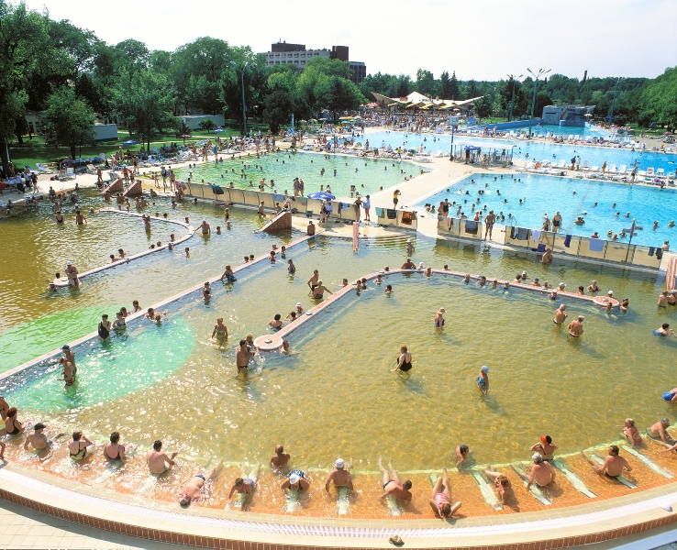

Scientific meeting

09.05.2009, Saturday

9.00-10.30 Scientific meeting Part I.
Chairperson: M. Zeki Karagülle and Tamás Bender

1.) Research in balneology in Turkey; an overview
M. Zeki KARAGÜLLE and Mine KARAGÜLLE (15 min)

2.) Balneological research in Hungary
BENDER Tamás (15 min)

3.) Spa based day hospital
GÉHER Pál and HORVÁTH Remény (10 min)

4.) Effects of Thermal Bath on Arterial Pressure in Healthy Subjects at Different Ages
Hatice GÜRDAL, Kağan ÖZKUK, Yasemin BARUT, Mine KARAGÜLLE (10 min)

5.) Does balneotherapy with low radon concentration in water influence the endocrine system? A controlled non-randomized pilot study
NAGY Katalin, BERHÉS István, KOVÁCS Tibor, KÁVÁSI Norbert, SOMLAI János, BENDER Tamás (10 min)

6.) Diagnostic Criteria for hand Osteoarthritis
Fitnat DINÇER (15 min)

11.00 -11.20 Coffee break

11.20 – 13.00 Scientific meeting Part II.
Chairperson: Mine Karagülle and Pal Geher

7. ) Mineral Waters and Osteoporosis
Mine KARAGÜLLE (10 min)

8.) The mud therapy in the St.Andrew Hospital
GYARMATI Noémi (10 min)

9.) Effects of Mud Packs on Local Rheumatic Diseases, A Case Series
Kağan ÖZKUK, Fatma Begüm BERKÖZ, Fulya ALDİNÇ, Mine KARAGÜLLE, M. Zeki KARAGÜLLE (10 min)

10) Effects of complex physiotherapy in Personage-Turner syndrome
HORVÁTH Ágnes and ANDITS Tamás (10 min)

11.) The effect of balneotherapy on quality of life in Fibromyalgia Syndrom
Nergis ERDOĞAN and Arif DÖNMEZ(10min)

12.) Effect of balneotherapy on work productivity in low back pain - a follow up study
KIRÁLY Márta and HODINKA László (10 min)

13.) Manual therapy sub aqua
ORMOS Gábor (10 min)

14.) Low intensity ultrasound therapy. A new possibility in the treatment of locomotor diseases
DONÁTH Judit (10 min)

15.) Bath in Seclerland
TEFNER Ildikó (10 min)

13.00 -14.00
Lunch with the Professors (scientific lunch)

VII. HUNGARIAN - TURKISH

BALNEOLOGICAL WORKSHOP
7-10 May 2009, Hajduszoboszló, Hungary

Social programme

Congress venue and accomodation:
Hungarospa Thermal Hotel, 4200.Hajdúszoboszló, József A. u. 25.
www.hungarospathermalhotel.hu
Tel: 00/36-52-558-553, 558-554 Fax: 00/36-52-558-556
E-mail: reservation@hungarospathermalhotel.hu

07.05.2009, Thursday
Afternoon:
12.45. Arrival of the Turkish Delegation to the Ferihegy Airport
Transfer by bus to Hajduszoboszló (about 200km)
Dinner in the Hungarospa Thermal Hotel

08.05.2009, Friday

Breakfeast in the Hotel
After breakfeast (appr. 9.30 a.m.):
Bus transfer for a whole day excursion to Hortobágy
Exhibition of the rich flora and fauna in the National Park.
Lunch served in a typical hungarian restaurant
Afternoon arrival back to the Hotel (appr. 6.30 p.m.):
Dinner in the Hungarospa Thermal Hotel

09.05.29 Saturday

14.00 Departure for tours and site visit
Sightseeing in Debrecen (Medical Univerisy)
Visit to Nyiregyháza Sóstó Spa,
Cave visit inTokaj-Hegyalja Wine-district(Dinner)
Bus transfer back to the Hotel

10. 05. 2009 Sunday
Morning:
Breakfeast in the Hotel
09.00 transfer to Budapest Ferihegy Airport
13.45 Departure to Istanbul

